Task 1:

Wap to create a class Student.. With 3 methods
registrationDetails(), marksCalc(), feesCalc().
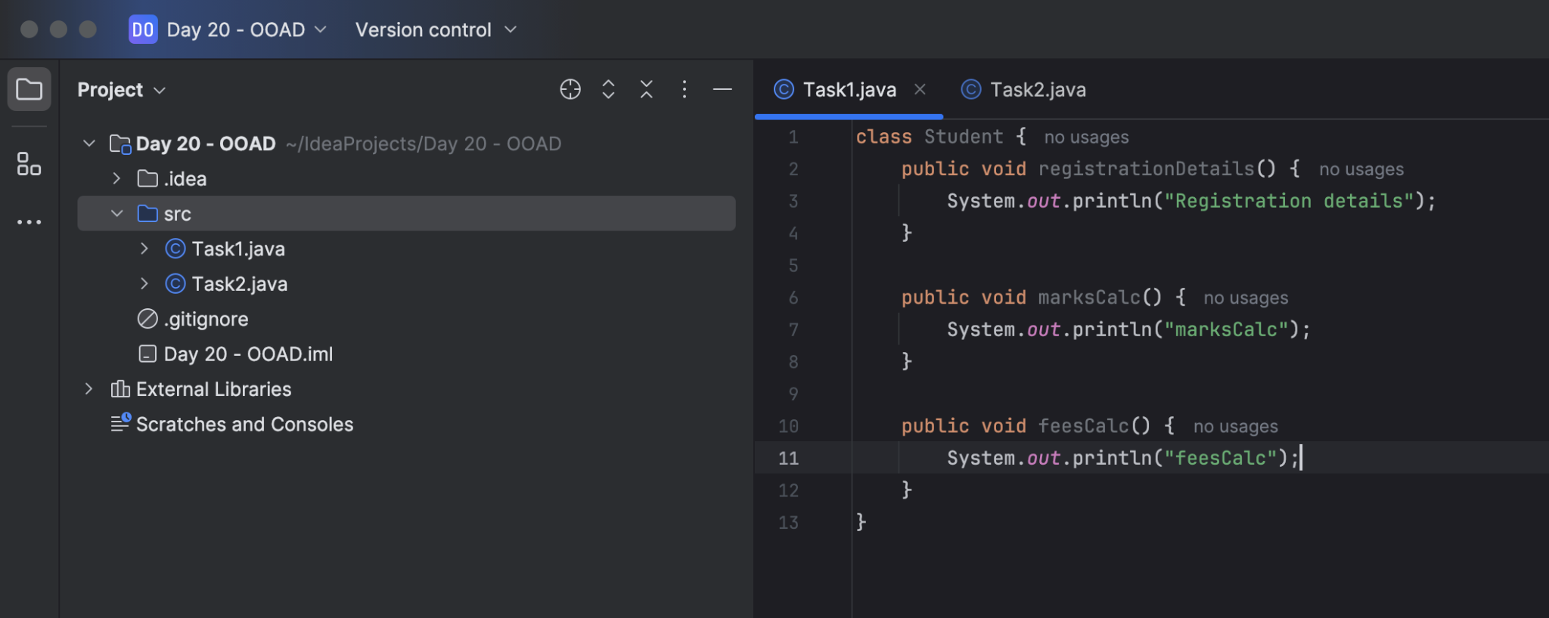

Task 02:

class Employee {
private String name;
private String email;
private double salary;

// Methods related to employee data

// Method to generate PDF report
public void generatePdfReport() {
// Code to generate PDF report
}

// Method to send email
public void sendEmail() {
// Code to send email
}
}
In the above example code, the Employee class violates the SRP because it has multiple responsibilities: managing employee data, generating PDF reports, and sending emails. These responsibilities are not cohesive and may change for different reasons.

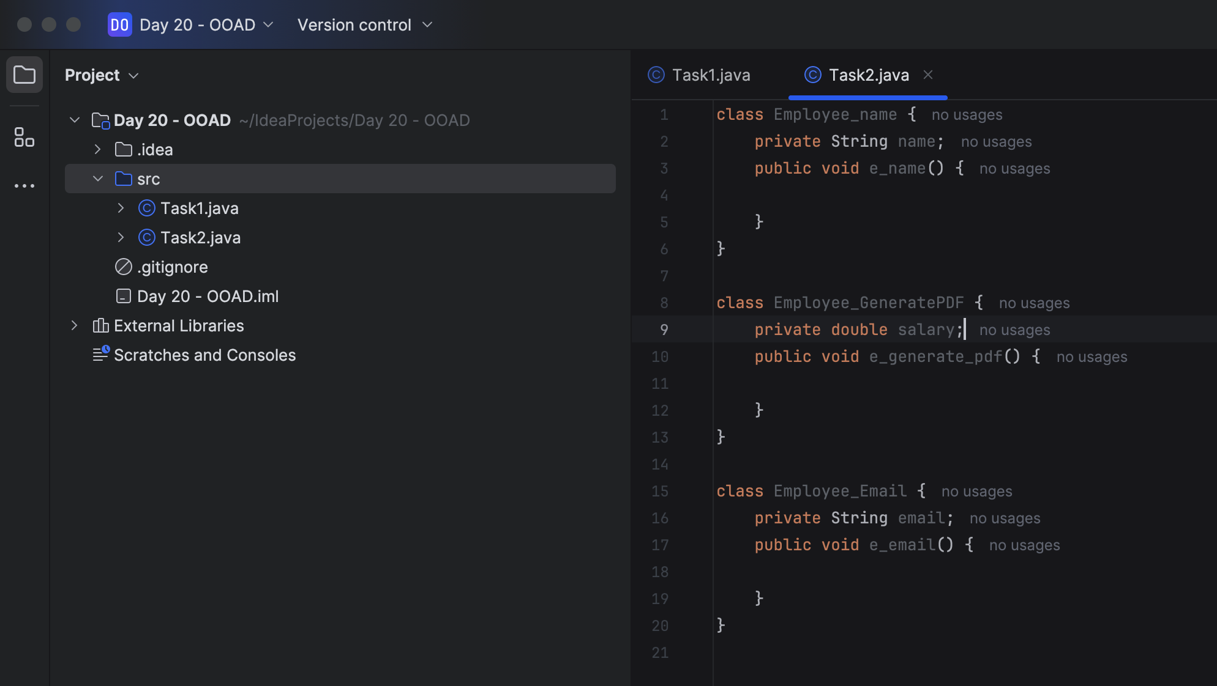

Task 03:

class PaymentProcessor {
public void processPayment(String paymentType, double amount) {
if (paymentType.equals("credit card")) {
// Process credit card payment
} else if (paymentType.equals("paypal")) {
// Process PayPal payment
} else if (paymentType.equals("bitcoin")) {
// Process Bitcoin payment
}
// ... more payment types
}
}

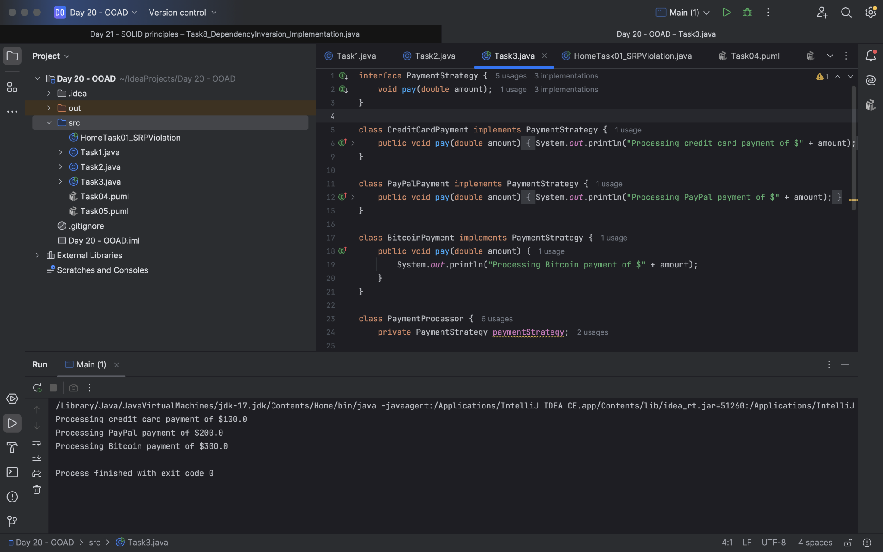

Task04:

Sequence diagram:

@startuml
Prasunamba -> Atlas_Batch1: Congratulations all
Atlas_Batch1 --> Prasunamba: Thank you Meher

Prasunamba -> Atlas_Batch1: Good luck for your Module 3
Atlas_Batch1 --> Prasunamba: Thank you Meher in advance
or
Prasunamba < -- Atlas_Batch1: Thank you Meher in advance
@enduml

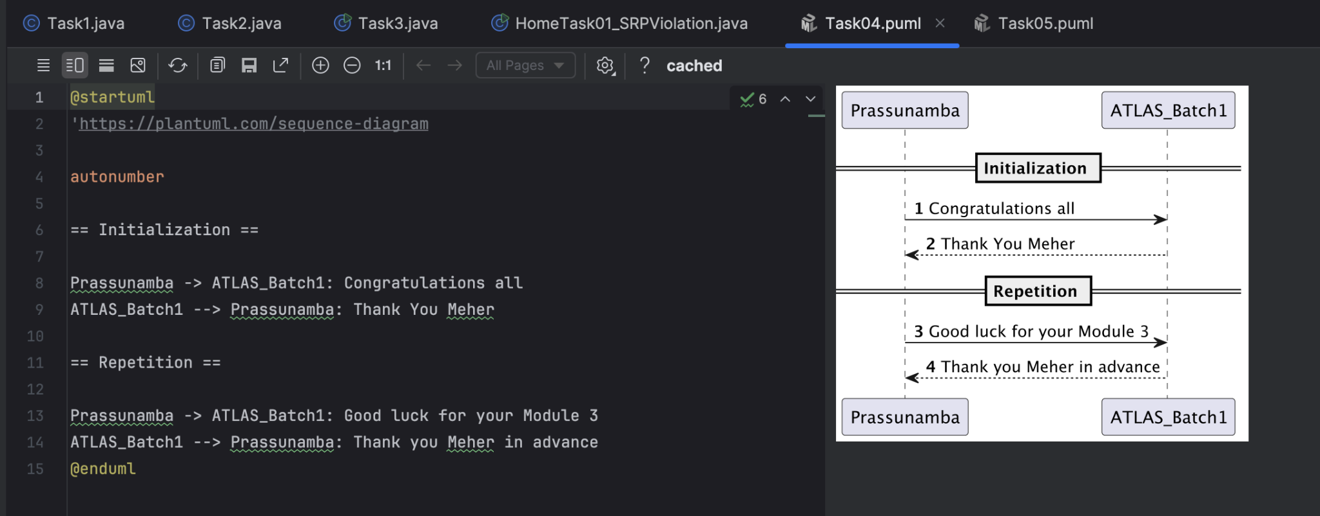

Task05:

@startuml
pax "A" as A
pax "B" as B

A --> B: Message/action
A ..> B: reply
@enduml

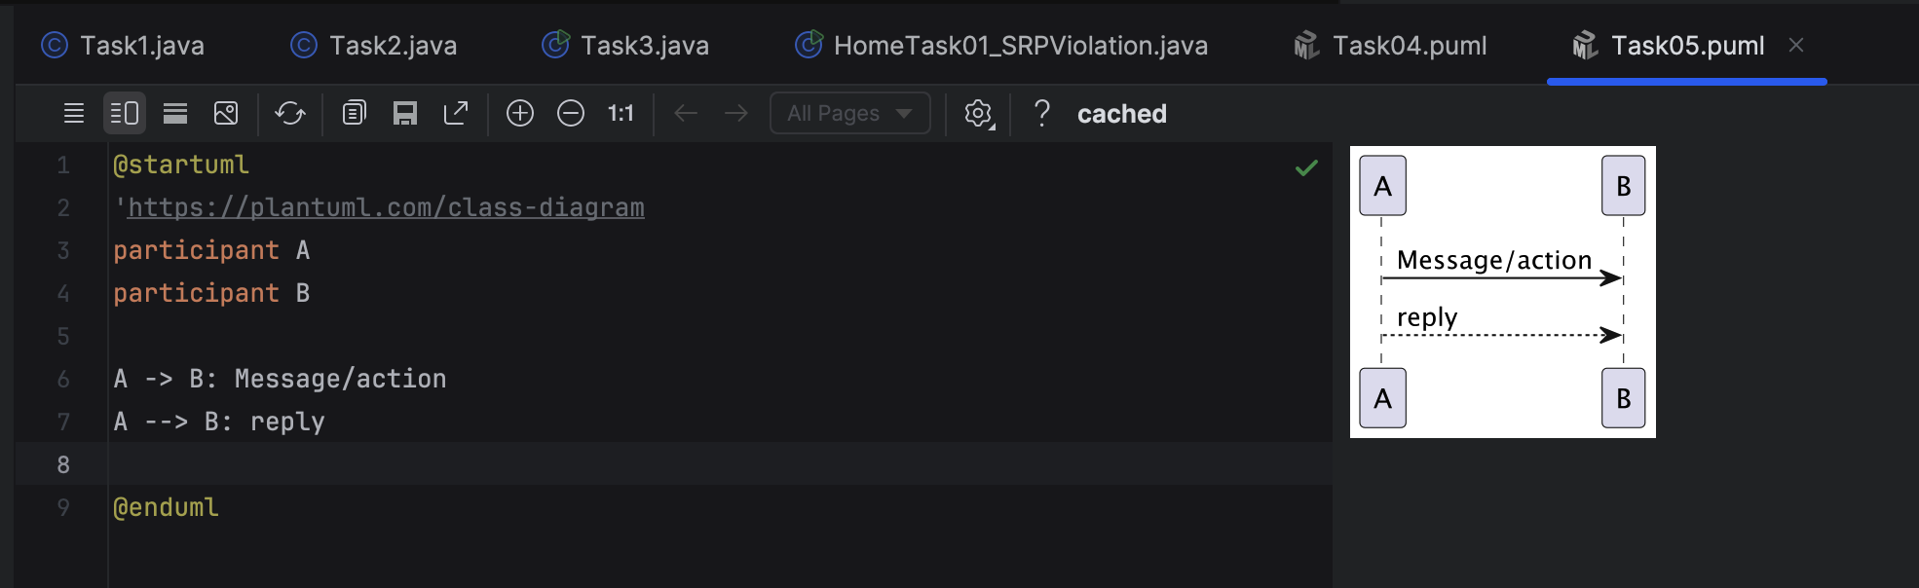

========================================================================

Home Tasks:

Task01

Try this code regarding SRP

The below is violating SRP complete it and also … plz implement the SRP principle and rewrite the code.
// srp violation

public class Book {
private String title;
private String author;
private double price;

public Book(String title, String author, double price) {
this.title = title;
this.author = author;
this.price = price;
}

public String getFormattedTitle() {
return "Title: " + title.toUpperCase();
}

public double calculateDiscountedPrice(double discountPercentage) {
return price * (1 - discountPercentage);
}

// ... other methods for book details
}

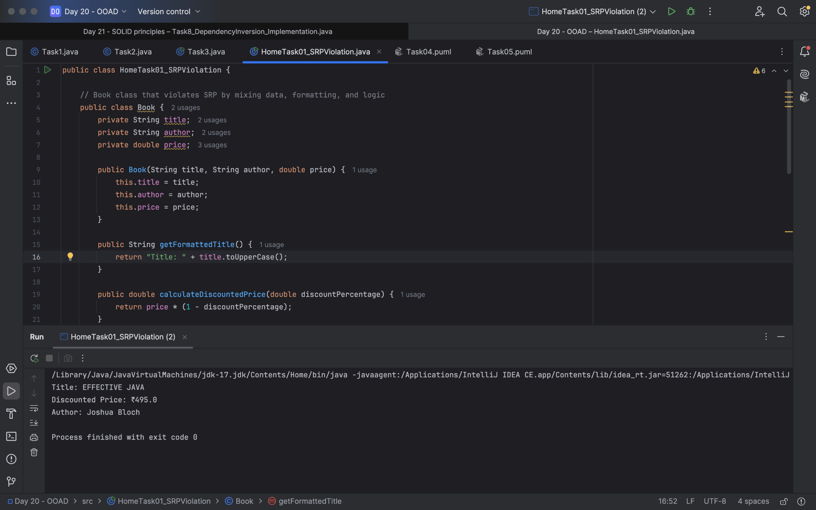

SRP implementation:

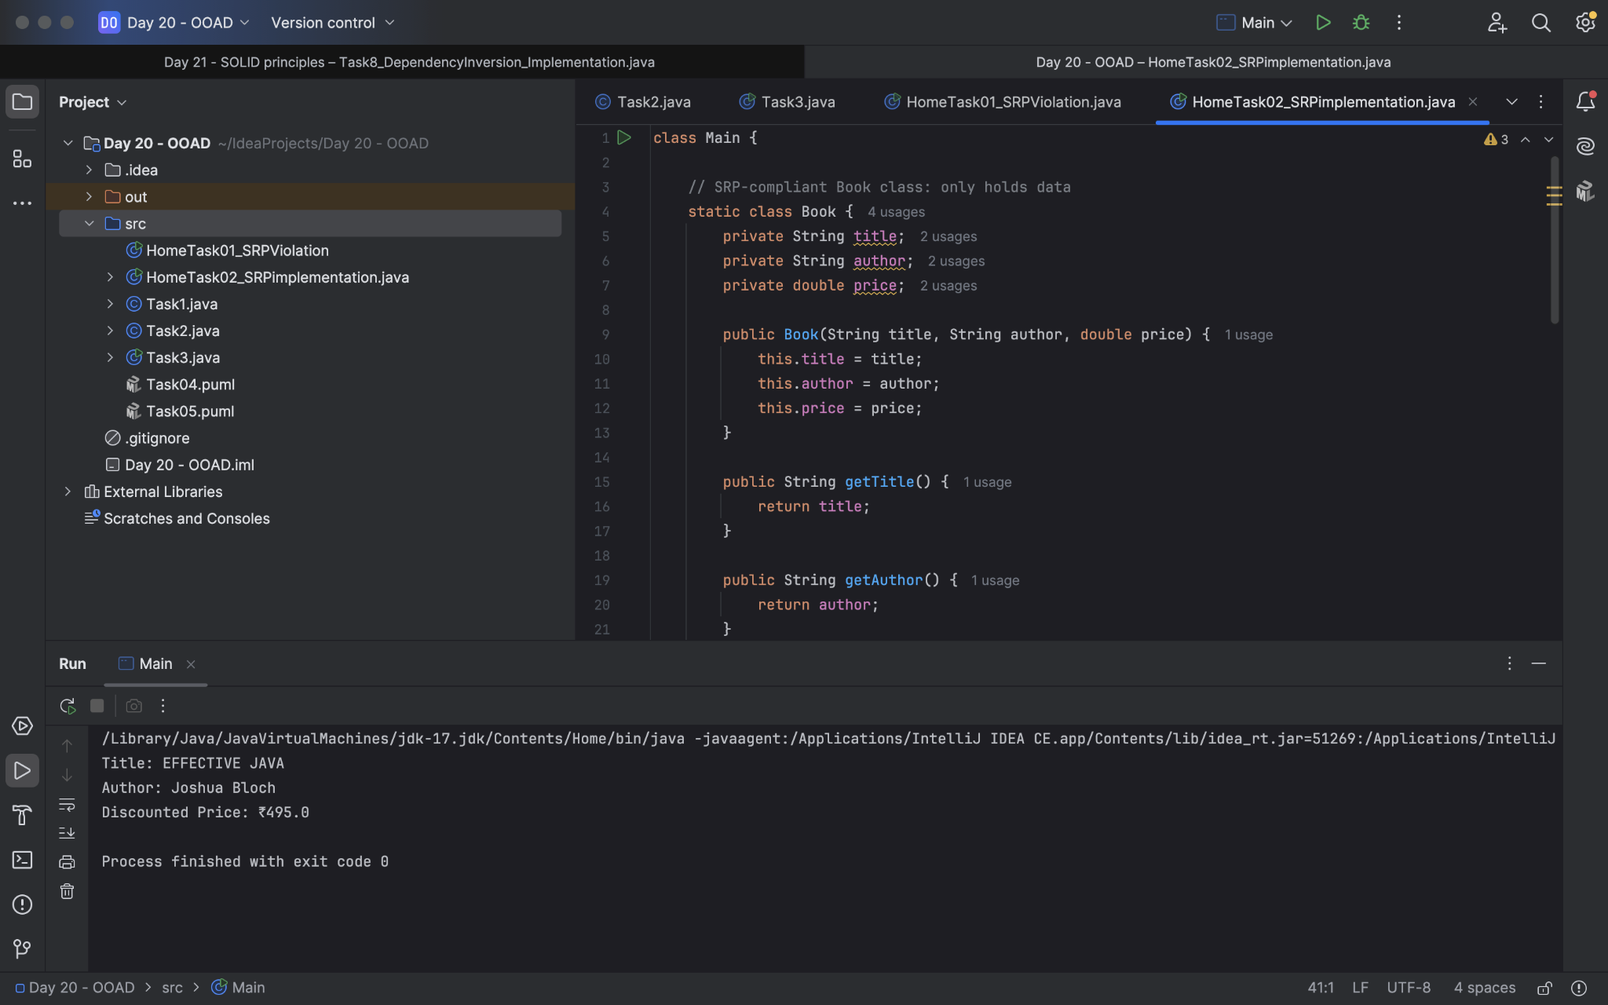
Home Task 02:

Without SRP:
SRP violation code

public class Customer {
String name;
String custID;

public Customer(String name, String custID) {
this.name = name;
this.custID = custID;
}
public String getName() {
return name;
}
public String getCustID {
return custID;
}
public void saveData() {
try{
FileWriter fw = new FileWriter(name+".txt");
fw.write("the customer name is "+ name + "\t");
fw.write("the customer id is "+ custID + "\t");
System.out.println("the data is saved in
the file with your name");
}catch(IOException ex) {
ex.printStacktrace();
}
}
psvm( String[] args) {
Customer cobj = new Customer(" prasunamba" , "C001");
cobj.saveData();
}
}

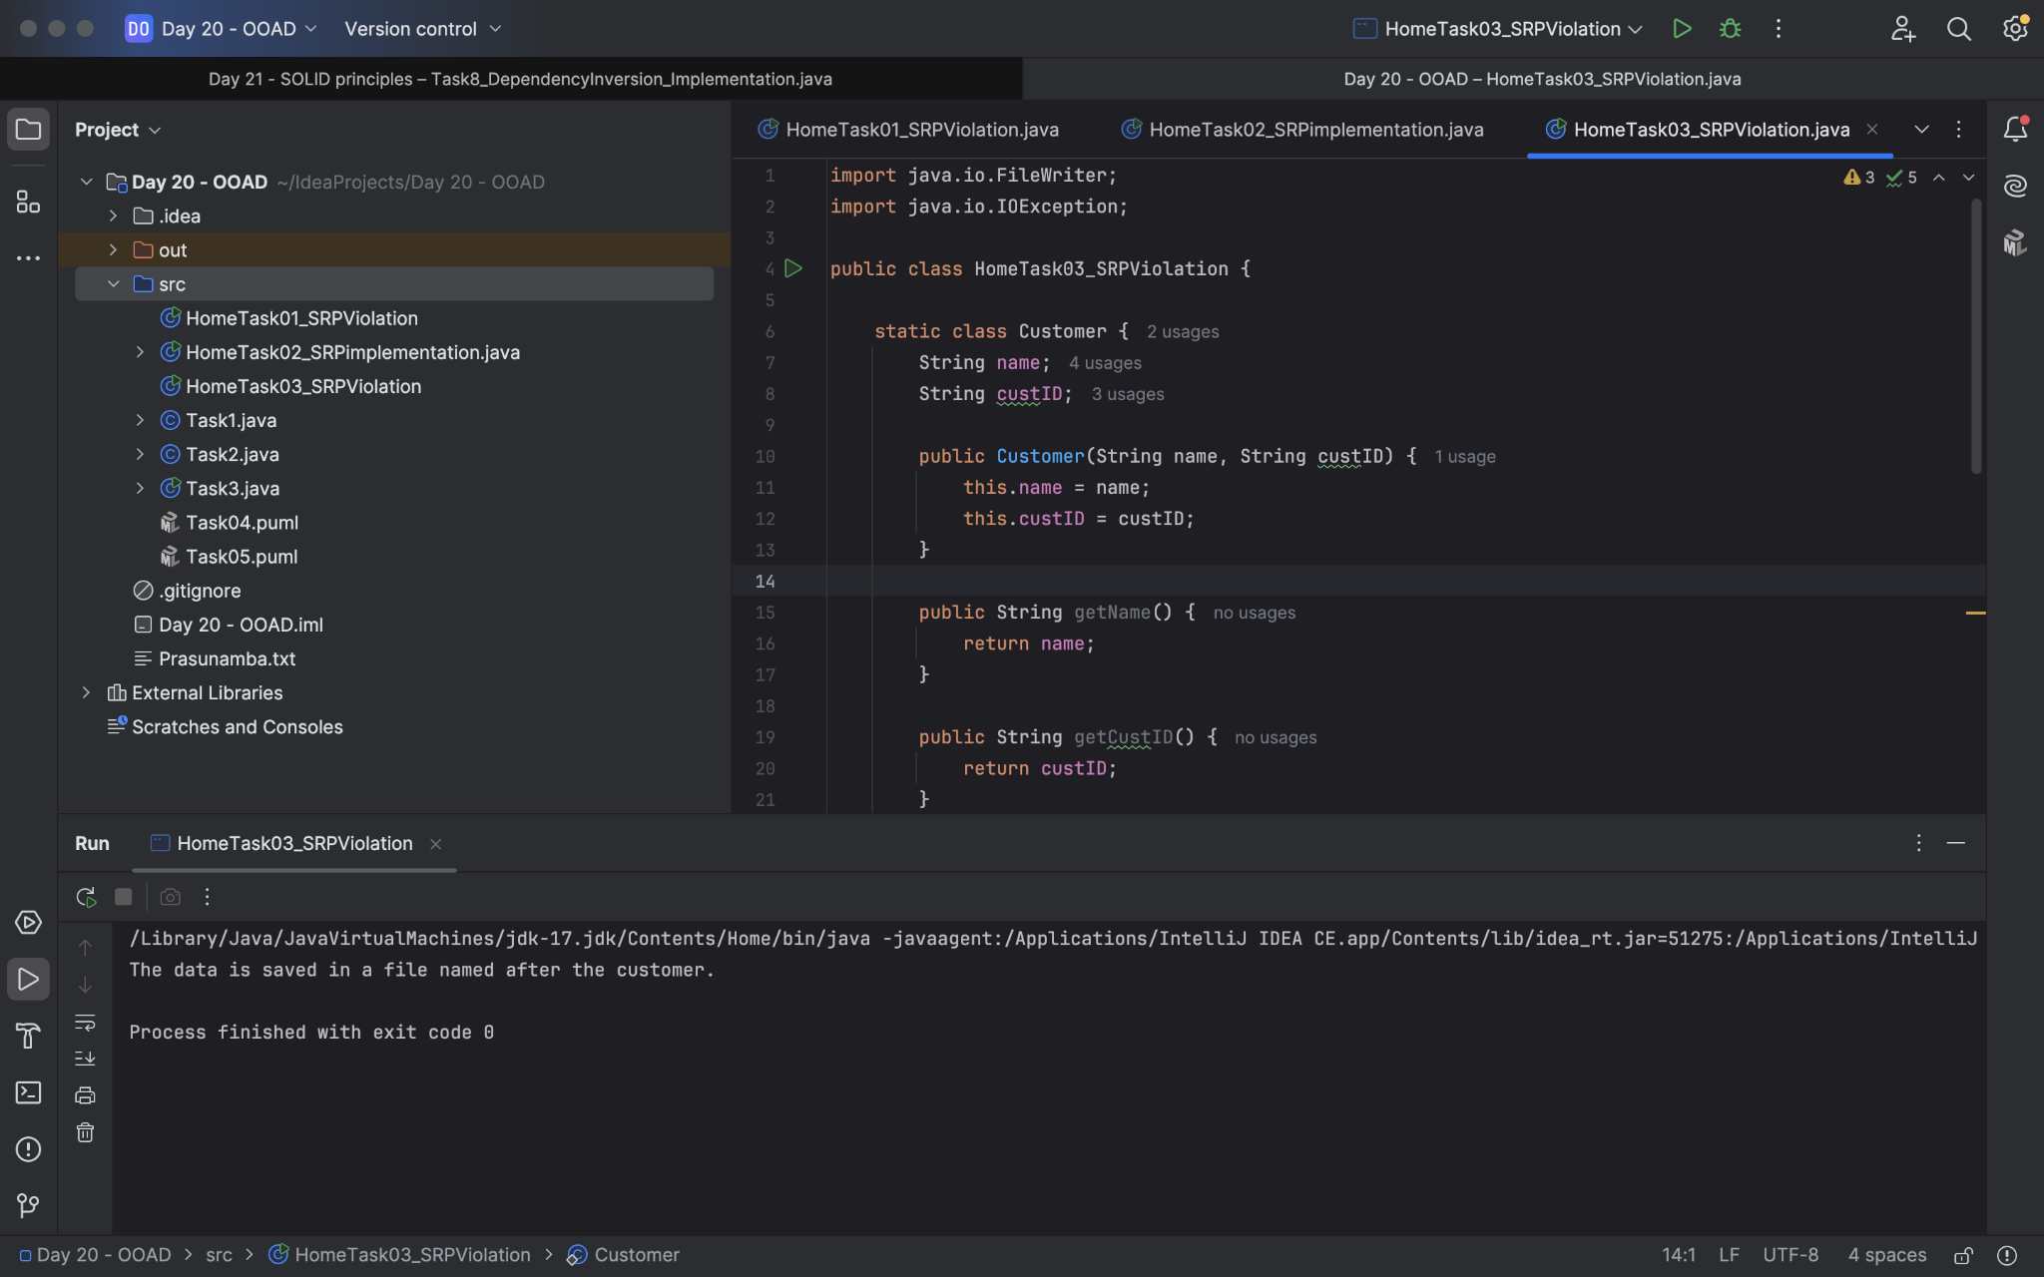

SRP Implementation:

